

**INFO 2302 WEB TECHNOLOGIES | Section 02**

**Dr. Aidrina Binti Mohamed Sofiadin**

Group 7

**README.MD**

‘SHARE4LIFE’ is a website for an online platform to help the needy by providing education resources.

|  |  |
| --- | --- |
| NAME | MATRIC NO. |
| MUHAMAD AIZAT NAZRAN BIN ROSLI | 1914785 |
| MUHAMMAD ARIF BIN ABDULLAH HALIM | 1916093 |
| MUHAMMAD AIMAN BIN RAZALI | 1916425 |
| MUHAMMAD AQIL IZDIHAR BIN SAHARUDIN | 1919801 |
| MUHAMMAD HAZIQ BIN SAMSUDIN | 1912481 |



‘SHARE4LIFE’

1. **Project Description**

On March 11, 2020, the World Health Organization (WHO) declared COVID-19 a global pandemic. The Coronavirus case has claimed more than 1.5 million human lives. The Malaysian government has taken the initiative to implement the Movement Control Order starting March 18, 2020 nationwide. All services or businesses are limited to operating to curb this pandemic. Indirectly, this has caused a huge impact on the less fortunate as a student. Therefore, we developed a website with the concept of online donation to help underprivileged students in International Islamic University Malaysia (IIUM). The website we developed is titled ‘Share4Life’. The system we developed is intended to help students who are affected by this Covid-19 case. For donors, they can channel aid such as money, food, educational devices, stationeries and some other necessities to help students.

This website building project that we developed includes the Home page as the main interface for this project. Next, on the 'Fund Donation' page we provide details to be filled by the donor such as name, email, phone number along with the amount of money to be channel and the Calculate button which serves as a calculation of the amount of money donated by the donor. On the 'Donation Form' page there are details such as first name, last name and email to be filled out by the donor. Donors also need to select the category of types of donations to be channel and there is a space that needs to be filled by the donor that is what items will be donated. Finally, on the 'Contact Us' page users can express their feedback such as suggestions, grievances or words of appreciation about our website.

There are some weaknesses in this system in which the organization of the picture and member’s details not neat. Other than that, there is no method of paying to donate money other than online banking. User can also donate their stuff by using by fill in the donation for but there is not stick to only one place to send stuff user want to donate. They need to set up place to send things they want to donate. So, it difficult for both party to meet up.

1. **Project Sitemap**

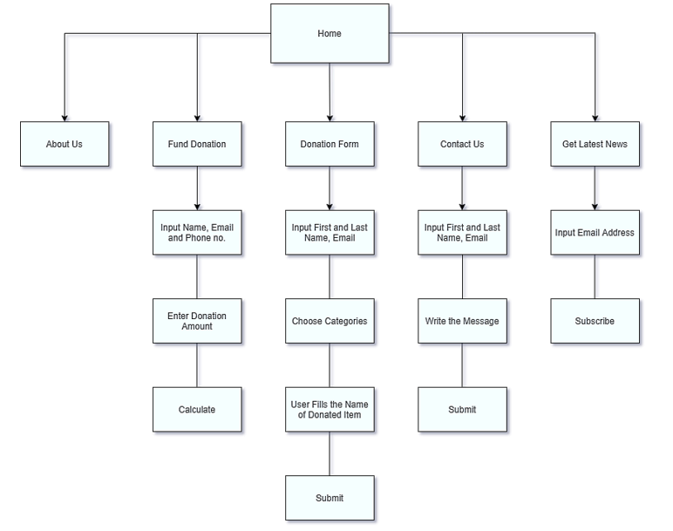

**3. Group Contributions**

|  |  |
| --- | --- |
| **Name** | **Contributions** |
| Muhammad Aiman Bin Razali | * Page: Home page * Web elements: navigation buttons, images, video, text area, form |
| Muhamad Aizat Nazran Bin Rosli | * Page: Fund Donation * Web elements: form, text area, calculation in donation amount, navigation buttons. * JavaScript event handlers for popup when calculate button clicked. |
| Muhammad Arif Bin Abdullah Halim | * Page: Donation Form * Web elements: form, text area, clickable dropdown, navigation buttons. * JavaScript event handlers for popup when submit button clicked. |
| Muhammad Aqil Izdihar Bin Saharudin | * Page: Contact Us * Web elements: required form, text area, navigation buttons. * JavaScript event handlers for popup when submit button clicked. * Base for website: Background, text, logo with suitable styling on all pages. |
| Muhammad Haziq Bin Samsudin | * Page: About Us * Web elements: images, text, navigation buttons. |

**4. Use of third-party resources**

|  |  |  |  |
| --- | --- | --- | --- |
| **Web elements** | **Name** | **Use of third-party resources and modifications (if any)** | **Modifications (if any)** |
| Background wallpaper for all pages | Black wallpaper | Used the website Wallpaper-House.com to get this image. This image is used as a background image for description on the home page. | The image is resized in the CSS. |
| HTML color codes | HTML color names | We used w3school website to get the color codes | - |
| Logo in homepage | Image of S4L | We used google chrome to find the image of S4L for Share4Life in homepage | The image is resized in HTML |
| Logo in homepage | Image of about us | We used google chrome to find the image for about us in homepage. | The image is resized in HTML |
| Logo in homepage | Image of cartoon money | We used google chrome to find the image of money cartoon for our goals in homepage. | The image is resized in HTML |
| Logo in homepage | Image of books | We used google chrome to find the image of books for our goals in homepage. | The image is resized in HTML |
| Logo in homepage | Image of laptop | We used google chrome to find the image of laptop for our goals in homepage. | The image is resized in HTML |
| Video on homepage | Video about donation | This video is taken from youtube.com. This video explain about donation. This video is shown in the homepage. | - |
| JavaScript about OnScroll | OnScroll Function | We used W3school website for references about OnScroll function. |  |

**5. References**

1. <https://wallpaper-house.com/data/out/9/wallpaper2you_326642.jpg>
2. <https://www.w3schools.com/tags/ref_colornames.asp>
3. <https://isteam.wsimg.com/ip/a1c2d4cf-2264-42a4-bab0-a469fcdbb313/logo/f2764abd-98ac-4690-bbf4-51e5f6b141a4.tif/:/rs=w:400,cg:true,m>
4. <https://www.susangreenecopywriter.com/wp-content/uploads/2013/01/iStock_000039291924_Medium.jpg>
5. <https://previews.123rf.com/images/stockgiu/stockgiu1910/stockgiu191034349/132609820-saving-money-cartoon.jpg>
6. <https://media.wired.com/photos/5be4cd03db23f3775e466767/125:94/w_2375,h_1786,c_limit/books-521812297.jpg>
7. <https://cdn.mos.cms.futurecdn.net/vEcELHdn998wRTcCzqV5m9.jpg>
8. <https://www.youtube.com/watch?v=K9vFWA1rnWc>
9. <https://www.w3schools.com/jsref/event_onscroll.asp>